REPINNING A CARD in CARD@ONCE
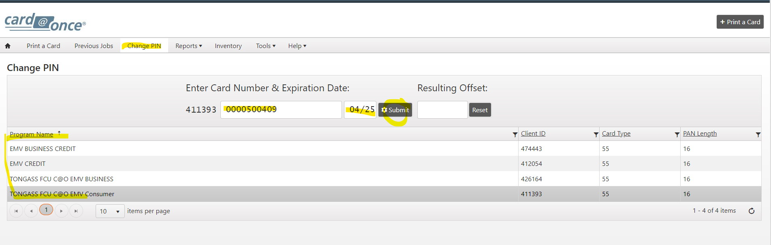
Select the type of card you are re-pinning. Then enter the card number and expiration date.
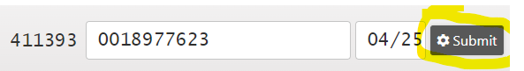
Click: SUBMIT

Green Bar saying OFFSET CALCULATED will appear if done correctly.
*RED BAR usually will mean an ERROR* Log out of CARD@ONCE and the internet browser and start again. *
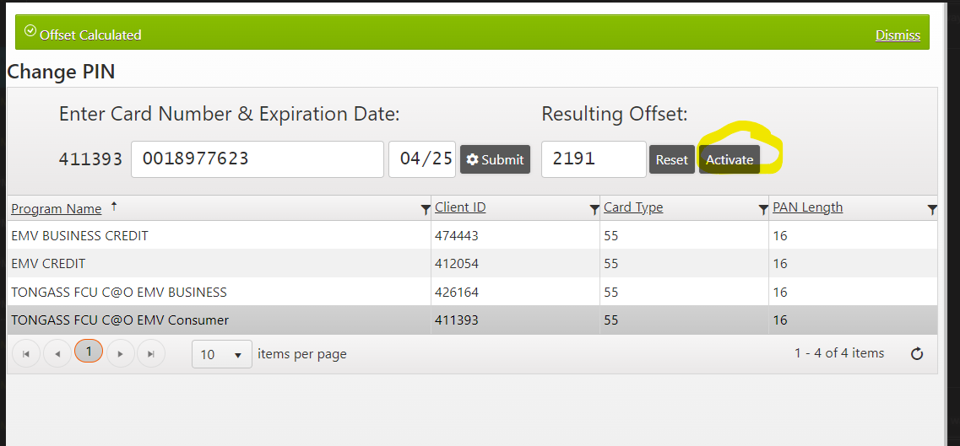
Resulting Offset: will be autogenerated a number (DO NOT DELETE OR RESET) Click: ACTIVATE

